**DAY 2: Morning Assessment**

1. Create a list of 5 integers and print them.

a=[1,2,3,4,5]

print(a)

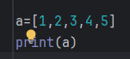

2. Create a list of strings and print each element using a for loop.

l=[“shreya”,”Bhoomi”,”sahil”, “bhargav”]

for name in l:  
 print(name)

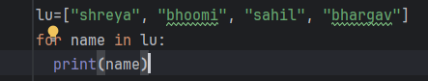 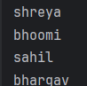

3. Find the length of a given list using len().

a=[1,2,3,4,5]

print(“length of the list is”, len(a))

 

4. Access the 2nd and 4th elements from a list.

a=[1,2,3,4,5]

print(a[1])

print(a[3])

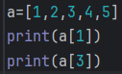 

5. Create a list of numbers and print a sublist from index 1 to 3.

a=[1,2,3,4,5]

print(a[1:4])

 

6. Add a new element at the end of a list using append().

a=[1,2,3,4,5]

a.append(6)

print(a)

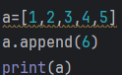 

7. Insert an element at the 2nd position using insert().

l = [10, 20, 30, 40, 50]

l.insert(1, 70)

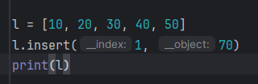



8. Add multiple elements to a list using extend().

l = [1, 2]

l.extend([3, 4, 5])

print(l)

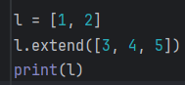 

9. Remove a specific element from a list using remove().

l = [1, 2, 3, 2]

l.remove(2)

print(l)

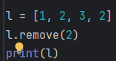 

10. Remove the last element of a list using pop().

l = [1, 2, 3]

l.pop()

print(l)

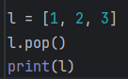 

11. Sort a list of numbers in ascending order using sort().

l = [4, 2, 1, 5, 3]  
l.sort()

print(l)

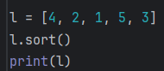 

12. Reverse a list using reverse().

l = [1, 2, 3]

l.reverse()

print(l)

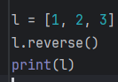 

13. Count how many times a specific element appears in a list using count().

l = [1, 2, 2, 3, 2]  
print(l.count(2))

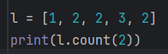 

14. Find the index of an element using index().

l = [10, 20, 30, 40]

print(l.index( 30))

 

15. Copy a list into another list using copy().

import copy

ori=[2.4.6.8.10]

copied=ori.copy()

print(copied)

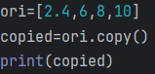 

16. Clear all elements from a list using clear().

l = [1, 2, 3]

l.clear()

print(l)

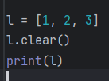 

17. Use list comprehension to create a list of squares from 1 to 10.

18. Create a nested list (list inside a list) and access an element from the inner list.

nested = [[1, 2], [3, 4], [5, 6]]

print(nested[1][0])

 

19. Check if a particular element exists in a list using the 'in' operator.

l = [1, 2, 3, 4]

print(2 in l)

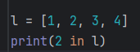 

20. Write a program to take 5 numbers from the user, store them in a list, and print the sum of all numbers.

